SYSTEMS & SCALE
ELEMENTARY

TEACHER GUIDE
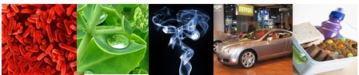

Environmental Literacy Project

Lindsey Mohan and Hui Jin
With help from Jonathon Schramm, Li Zhan, Valencia Moses, Jim Ratcliffe, and Andy Anderson

February 2009

Outline of Activities:

Outline of Activities: 2
Unit Overview and Background: 3
Embedded Assessments: 6
Materials List: 7
Activity 1: Visible and Invisible 9
Activity 2: Powers of Ten As a Tool 14
Activity 3: Using Powers of Ten 17
Activity 4: Materials and Needs 23
Activity 5: Investigating Air as Form of Matter 30
Activity 6: What is Energy? (Forms of Energy) 38
Activity 7: How Does Energy Change? 45
Activity 8: Energy and Fuels 50
Activity 9: Air is a Mixture 55

Unit Overview and Background:

Our work on the Environmental Science Literacy Project has been to document the accounts students have for events that occur in natural and human social systems. At the macroscopic scale we documented students’ accounts of growth, weight loss, decay and burning and at the large scale we looked at their accounts of global warming and deforestation. The goal of our work has been to develop a learning progression that describes how accounts of changes in matter and energy develop from grades 4-12. One important conclusion from this work, and our experiences in classrooms, is the following: When students enter school they use narratives (or stories) to explain how the world works. This is the students’ natural discourse. The information they learn in science class teaches them more detailed narratives and new vocabulary, and students try to fit the new information into their existing narratives. Thus, students tell the same stories with more details, instead of learning new, more principled accounts about their world.

Our carbon cycle learning progression describes what we observed from students at different levels (and different age groups). We used this information to design classroom materials that support (productive) progress toward building new accounts about the world—specifically to build principled accounts about carbon cycling.

The carbon cycle learning progression levels: Our learning progression is comprised of four Levels of Achievement:
- Level 1 students (at the lower anchor of the learning progression) use force-dynamic reasoning (Pinker, 2007; Talmy, 1988) in which actors (e.g., animals, plants, flames) use enablers (e.g., air, water, food, fuel, sunlight) to fulfill their natural tendencies. Events result from the interplay between the natural tendencies of agents and the balance of forces between enablers that support actors in fulfilling their capacities, and antagonists, which can prevent this from happening.
- At level 2 students are still guided by force-dynamic reasoning, but can point to hidden mechanisms that move beyond natural tendencies and begin to recognize the need to trace materials in and out of systems. Gases are treated more like conditions as opposed to “real matter” and matter and energy are not distinguished.
- At level 3 students begin to recognize chemical changes at a cellular and atomic-molecular level and use chemical identities for several important substances. Some level 3 students attempt to conserve both matter and energy without necessarily knowing great detail about chemical substances and processes. However, some level 3 students also may have difficulty with consistently applying conservation principles (i.e., convert matter and energy; ignore gases).
- At level 4 students see events as “chemically” similar or different and can reason about events in terms of chemical substances and processes. They can also fluidly move between different scales in their reasoning.

In general, most elementary school students give level 1 (42%) and 2 (39%) accounts on our assessments. Only 6% of students give level 3 accounts. Therefore, an important goal for elementary school students would be to get more students to consistently use level 2 and 3 reasoning. This involves supporting students in recognizing and using important principles to guide their reasoning and to move beyond the visible, macroscopic scale. In particular, this unit helps students use SCALE, MATTER, and ENERGY principles and introduces students to several tools that support reasoning with these principles. Furthermore, the frameworks and tools used in this unit are instrumental to subsequent units about living and human-engineered systems.

Activities 1-3 introduce students to the idea that systems can be understood at multiple scales. An important goal for this unit is to help students gain understanding of 4 benchmark scales (atomic-molecular, microscopic, macroscopic, and large-scale) that can help students compare the size of systems. At the elementary level, there are 3 key benchmark scales, because atomic-molecular scale is not age appropriate at this point. Students use Powers of Ten as a tool for locating and comparing systems at different scale. During Activity 1 students define the terms “system” and “scale” and view the Eames Brothers’ DVD on Powers of Ten. Students think about what appears and disappears as you zoom in and out of Powers of Ten. They also classify these systems in terms of the benchmark scales. Then Activity 2 uses a Powers of Ten powerpoint to look closer at a more limited range of scales from 10⁸ (Earth) to 10⁻⁹ (Molecules). The teacher can use this powerpoint to review the different Powers of Ten and to think about how the four benchmark scales map onto the Powers of Ten. During Activity 3 students have an opportunity to try to locate systems on the Powers of Ten and discuss how their predicted locations match the actual location of those systems. They place systems onto the chart and categorize those systems in terms of the benchmark scales.

Activity 4 and 5 are about matter. Activity 4 has students consider different types of materials, and ultimately has students look at materials in terms of solids, liquids, and gases. In Activity 5 students engage in investigations and demonstrations that air is matter- they think about macroscopic evidence of air. They will revisit air in Activities 8 and 9 when they talk about air being a mixture and organisms and flames can change this mixture.

The choice of looking at air during Activity 5 was intentional because gases are particularly problematic for students. The topic of air causes difficulties for students because air is a complex mixture of gases that are generally colorless, odorless, and thus undetectable except by indirect means. Many important phenomena, including photosynthesis, humidity, smells, pollution, and the water cycle, are associated with variations in the mixture of molecules in air. Students must learn to see air and other gases as forms of matter like liquids and solids, with all the characteristics of matter in general: -- air is made of molecules -- air takes up space. Activity 5 does not begin to cover the complexities associated with understanding gases as a form of matter, but it does introduce students to the idea that matter can be viewed at different scales AND students think about how matter can look different at one scale (macroscopic) while it is really quite similar at another (atomic-molecular).

Activity 6 introduces students to forms of energy. Based on their daily life, students have constructed a lot of ideas about energy. In their mind, energy is mostly associated with movement, activities, or life. Energy can also be a kind of semi-material which can appear and disappear mysteriously or can be converted from or into matter. All these ideas conflict with the scientific meaning of energy. In science, energy is an abstract quantity associated with certain evidences, such as light, sound, foods/fuels, etc. It cannot be converted from or into matter except in nuclear reactions. In this activity, we first introduce the notion of Energy Forms and a list of energy forms is introduced with explanation about how to identify each energy form based on its evidence. Then in Activity 7 (which can be completed in conjunction with Activity 6) students observe how several scientific toys work and figure out how energy transforms in each event. Students are expected to understand energy transformation in this activity. The teacher can use the large-scale process tool and/or the how can machine work powerpoint to discuss the difference energy transformations. The next activity (Activity 8) will add matter transformation to the process tool.

The purpose of this Activity 8 is to use combustion as an example to introduce the process tool with both matter transformation and energy transformation. Activity 8 is also a bridge to help students connect their macroscopic experience of burning, with how materials and energy are changing. Burning is treated as a process in which fuels or air are constantly consumed by flame. Some students may recognize that materials change, but gaseous reactants or products such as carbon dioxide, oxygen, and water vapor are usually not identified. In summary, most students do not hold the idea that the materials change chemically into other materials. So, in the lab, students observe what happens when a candle burns and identify the materials (especially the gas reactant and products) involved in burning. The use the process tool to help them identify how both matter and energy change during burning, and the teacher uses the large process tool and/or powerpoints to explain matter and energy transformations.

The final activity revisits air. Students learn that air is a mixture and they consider how the flame in the candle changed this mixture. They also consider how organisms (plants, animals, and decomposers) change the mixture of air. This activity serves as a bridge for other units on organisms and human energy.

Embedded Assessments:

Please make copies of these student worksheets for the 12 focus students and mail to environmental literacy project.

- Visible and Invisible (page ES SS – 12)

- Needs of Living Organisms (pages ES SS – 28-29)

- My Observations of Air (pages ES SS – 36-37)

- My Ideas about Energy (page ES SS – 40)

- How Can Machines Work? (pages ES SS – 48-49)

- Burning A Candle (pages ES SS – 53-54)

- How Is Air Changed (pages ES SS – 59-60)

Materials List:

TEACHER TOOLS
Overhead projector, blank transparencies, vis a vis markers (also chart paper or chalkboard)
Computer and projector if powerpoint.
Powers of 10 DVD
Comparing Powers of 10 Poster
Energy “Toys”
Lamp
Large Process Tool with Velcro matter/energy/process labels

OVERHEAD TRANSPARENCIES AND/OR POWERPOINTS
Visible and Invisible
Comparing Powers of 10 Overhead Transparency: Blank
Comparing Powers of 10 Overhead Transparency: Partial
Comparing Powers of 10 Overhead Transparency: Full
1 set of transparency Enabler Cards and/or 1 set of enlarged teacher Enabler Cards
Powers of Ten powerpoint OR transparency slides of the powerpoint
Process Tool powerpoint for How Can Machines Work

STUDENT WORKSHEETS (30 total, 1 per student, students write on)
Visible and Invisible
Needs of Living Organisms
My Observations of Air
My Ideas about Energy
How Can Machines Work?
Burning A Candle
How Is Air Changed

COLLECT AND RE-USE STUDENT MATERIALS(30 total, 1 per student)
Comparing Powers of 10 Answer Key
Energy Forms
Air is a Mixture (and What Gases Make up Air)

COLLECT AND RE-USE GROUP MATERIALS (1 per group/ 8 per teacher)
Blank Powers of Ten group posters
Powers of Ten Cut-outs
Poster Putty/Scissors
Enabler Cards

LAB MATERIALS
Aquarium or large container filled with water
2-3 clear plastic party cups
1 tissue paper
Lots of balloons
1 gym ball
1 ball pump or small air compressor
Scale sensitive to 0.1g or 0.01g (the more sensitive the better)
Fizz keeper
Empty soda bottles
Wide mouth water or juice bottles
Alka seltzers
Candle
Lighter
Large glass container or beaker

Activity 1: Visible and Invisible

General Overview:
Introduction: What does “system” and “scale” mean to you? ~ 10 minutes
Whole class: Powers of 10 video ~ 20 minutes
Whole group: Discussion of video ~ 10 minutes
Whole group: Visible and Invisible ~ 20 minutes

Estimated Time: 60 minutes

Purpose:
The lesson introduces students to the terms “system” and “scale” and also introduces students to Powers of Ten. Students at the elementary school level are likely aware of different scales, but describe systems and processes at the macroscopic scale because it is visible. They often do not explain what is happening on smaller and larger scales that are connected to what they can visibly see. This activity teaches students about 4 benchmark scales. The lesson begins by eliciting students’ understanding of microscopic, macroscopic, and large-scale systems. The students then watch the Powers of 10 DVD (17 minutes), a video that shows the relative size of systems, from galaxies to subatomic particles. The video is approximately 17 minutes, but if time is an issue, the introductory material at the beginning of the video can be skipped (view video ahead of time to determine whether or not to use the full 17 minutes). This DVD goes far beyond the content that elementary students should be expected to know. The range elementary teachers and students should be most interested in is between 10⁻⁶ (micrometer; cells) to 10³ (kilometers) although some teachers at upper elementary may be comfortable with introducing molecules (10⁻⁹). The video should be used as a starting point for 1) introducing students to ‘scale’ as one way to compare different systems, 2) encouraging students to use the general heuristic about three benchmark scales: microscopic, macroscopic, and large-scale with a focus on the latter three, and 3) providing students with a Powers of 10 framework for comparing the relative size of different things. Note that atomic-molecular scale is a 4th benchmark scale that will receive some, but limited, attention in the activity.

Materials:
Powers of 10 DVD
Student copies of Visible and Invisible
Transparency of Visible and Invisible
Overhead projector & vis a vis markers

Advance Preparation/ Safety Considerations:
- Review Powers of 10 DVD before lesson (17 minutes) and decide how to use the DVD- as noted the DVD goes beyond the content expected of elementary kids. The teacher may want to select places to “pause” or places to fast-forward or rewind depending on what is deemed appropriate for the students.
- Gather copies of Visible and Invisible student handouts sent from MSU
- Gather copies of Visible and Invisible transparency sent from MSU

Procedures/Suggestions:

Introductory discussion: Systems and Scale ~10 minutes
- Before watching the video, it is important that students have some understanding of ‘systems’ and ‘scale’. You should spend the first 10 minutes developing a reasonable definition for these terms with your students. Some possible discussion questions and definitions include:
  - In science we look at different “systems”. What does this term mean to you? What do systems have in common that make them “systems”? Possible definition might include: Set of interacting components (or pieces) that are connected to one another.
  - In science we look at many different things throughout the year. Some of these things we can see with our eyes, but other things we cannot see. Some things are at a scale too small to see and other things are at a scale too large to see. What does the term “scale” mean to you? What does the word “scale” mean to you? (try to cue students to move beyond measuring scales, such as weight scales). Possible definition might include: range of measurement used for comparing pieces in a particular system or comparing two different systems. By changing scale you can compare the sizes of systems (or size of different things).

Powers of 10 video ~20 minutes
- Explain to students that they will watch a short film looking at different systems from different scales. Students might want to take mental notes of what they see in the video, however, the images will change quicker than most will be able to write notes down. Let students know that the DVD can be paused to allow them to further discuss particular images (and to slow the speed down for elementary students). Because the video contains content beyond what elementary students need to know the teacher may choose to skip over the very large and very small scales and stay within the solar systems to molecules range.

Discussion of Video and Scale ~10 minutes
- Allow students to reflect on the video and share their ideas regarding systems and scale. What things did the students see in the video? What scales were used to look at these different systems? This is an opportunity to find and discuss images on the video. As a class, develop a common understanding of the terms microscopic, macroscopic, and large-scale. These are the 3 key benchmark scales that elementary students should learn and be able to use. The teacher may want to write these words on the board or overhead. Encourage students to dissect the words, for example, discussing what “scopic”, “micro”, and “macro” mean. Do all systems fit into the categories microscopic, macroscopic, and large-scale? Usually the idea of something being microscopic implies that it can be seen with any microscope; however, when viewing atoms and their parts (electrons, protons, and neutrons) it involves tools much stronger than a typical classroom microscope. At this point the teacher can introduce a 4th benchmark scale, atomic-molecular, but remember to focus on the original three scales.

Visible and Invisible ~20 minutes
- Pass out student handouts entitled Visible and Invisible. For the remainder of class students will begin thinking about things that are too small and too large to see with the human eye. Give students approximately 5-10 minutes to work individually or with partners to complete the handout. They will develop three broad categories for these things. The students can contribute their own new ideas to the list, and use information shared in the video. Tell students that they will share their list with the group. They should also think about the two questions at the bottom of the handout. After ten minutes, use the Visible and Invisible overhead (or chart paper) to record students’ ideas. Make sure to gather a complete list from the class and focus on areas in which students may disagree. Then as a class share what students wrote to the two discussion questions. The goal is for students to see that things at different scales can be connected to one another. For example, a cell is connected to a hand and a car running is connected to global warming.
Name: _____________________________________ Date: ________________

Visible and Invisible

The Powers of Ten video showed really large things and really small things that people are unable to see with their own eyes. People need microscopes to see really small things. They use telescopes to see really large things. People also use models to represent really small and really large things, such as a globe used to show the Earth.

With your classmates, try to think of all the things that may be too small or too large to see with the human eye, and things you can see with the human eye. List the things in the Table below.

TOO SMALL TO SEE WITH HUMAN EYE  (microscopic and smaller) | CAN SEE WITH OUR EYES  (macroscopic, visible) | TOO LARGE TO SEE WITH HUMAN EYE  (large-scale)
DNA  Cells (white blood cells; skin cells)  Atoms  Molecules  Bacteria  Air (molecules)  Other possibilities | Skin  Body and body parts  Plants  Animals  Cars  School bus  Paper  Pencil  Chair; Furniture  Food  Other possibilities | Earth  Solar systems  Galaxies  Large Ecosystems  Big Cities  Other possibilities

Questions:
- How are really small things part of the visible things we see with our eyes?
Small things make up the things we see

- How are really large things connected to the visible things we see with our eyes?
All things are connected in systems, like ecosystems or earth systems. All the things we see make up the large systems

Visible and Invisible

TOO SMALL TO SEE WITH HUMAN EYE  (microscopic and smaller) | CAN SEE WITH OUR EYES  (macroscopic, visible) | TOO LARGE TO SEE WITH HUMAN EYE  (large-scale)

Activity 2: Powers of Ten As a Tool

General Overview:
Introduction to Powers of Ten Powerpoint ~ 20 minutes
Mapping Benchmark Scales onto Powers of Ten Chart ~ 10 minutes
Powers of Ten Chart and Practice placing Items ~ 20 minutes

Estimated Time: 50 minutes

Purpose:
The students have watched the Powers of 10 DVD, a video that shows the relative size of systems, from galaxies to subatomic particles. They have also learned definitions for the words “systems” and “scale” and learned about 3-4 benchmark scales: atomic-molecular, microscopic, macroscopic, and large-scale. In this second lesson, the Powers of 10 chart will be used as a framework for comparing systems at different scales, for example, comparing the size of molecules to cells and cells to leaves, etc. The teacher will first use a set of powerpoint slides to bridge what students saw in the Powers of Ten video to using Powers of Ten as a comparative tool. The Powers of Ten powerpoint slides zoom in and out from Earth to molecules. Then students practice mapping benchmark scales to the Powers of Ten chart, and they will also begin mapping systems to charts. The goal of this lesson is to give students more practice with understanding scale and to help students see how Powers of Ten and the benchmark scales are both useful ways of comparing systems.

Materials:
Power of Ten (New).ppt (powerpoint) Or overhead transparencies of the ppt slides
Computer and projector OR overhead set and overhead projector
Comparing Powers of 10 Overhead Transparency: Blank (from master)
Comparing Powers of 10 Overhead Transparency: Partial answers (from master)
Blank Powers of Ten group posters
Small set of Powers of Ten cut-outs
Overhead projector & vis a vis marker

Advance Preparation: If not completed by MSU
- View Powers of Ten (New) powerpoint and practice projecting this powerpoint in classroom OR make overhead copies of each slide to use on overhead/opaque projector.
- Gather overheads for Comparing Powers of 10 (blank, partial)
- Gather poster-size copies of Comparing Powers of 10 Group Chart (blank) for each group
- Gather color copies of Comparing Powers of 10 Cutouts (students will only use a small set of these today, but will use all of them during Activity 3)

Procedures:
Introduce Powers of Ten using Powerpoint slides ~20 minutes
A powerpoint slideshow has been developed as a way of bridging the Powers of Ten DVD viewed during Activity 1 with the Powers of Ten charts that are used in Activities 2 and 3 and throughout other classroom activities. The Powerpoint allows the teacher and students to zoom in and out at various steps similar to the DVD. This format allows the teacher to go step by step through various systems and scales and talk about the size of the system (and start making comparisons to other systems).

There are 2 ways to use the powerpoint slides: Either on a computer projected to the class or by printing off overheads of the powerpoint slides and showing them on an overhead projector.

The powerpoint corresponds with many images of the Powers of Ten DVD but some images have also been replaced.

First have students review what they learned about systems and scale from Activity 1. Also ask students to share what they learned about the three key benchmark scales. Remember that students may also talk about atomic-molecular scale as a 4th benchmark scale.

Then use the powerpoint slides to teach about systems and scale. For each slide first ask students what the system is (i.e., a solar system, planet, flower, virus, etc). Ask students what benchmark scale the system belongs to (i.e., atomic-molecular, microscopic, macroscopic, or large-scale). As you get to the most familiar systems (Earth, cities, flowers, cells, virus, DNA), start modeling how to use the Powers of Ten to compare systems. These comparisons may be difficult for students, particularly those who struggle with math. As you model comparisons, pick examples from the familiar objects. For example, you might say, “A virus is 1 micrometer, but bacteria are 10 micrometers. That means bacteria are roughly 10 times larger than viruses”.

While the most important goal for elementary school students is to have them learn and use the key benchmark scales, the Powers of Ten can also be a useful tool for comparisons. At this age level consider focusing on the most familiar scale comparisons (i.e., systems at a meter are 100 times larger than systems at a centimeter, systems at a centimeter are 10 times larger than something at a millimeter, etc). Stay within the range of cells to meters.

Introducing Powers of Ten Chart ~25 minutes
Introduce the “horizontal” powers of ten charts to students using the blank Powers of Ten overhead transparency. Explain that this new chart is a second way of representing the Powers of Ten chart and make comparisons to powerpoint slides. At this time consider mapping the powerpoint systems on the chart to bridge what students learned in the powerpoint slides to what they will be doing next with the powers of ten charts. Use a wet erase pen to write these items on your blank powers of ten overhead.

As you map items from the powerpoint to the chart, explain the axis on the chart and how to use Powers of 10. Although students may be familiar with powers of 10, they may not realize how to use it to compare the size of objects. One idea to emphasize here is that when you are comparing across such a wide range of scales, you don't need to know exact sizes of objects- that the powers of ten are helpful in making estimates about sizes and differences in scale.

Now that several items from the powerpoint are mapped onto the blank powers of ten overhead transparency, allow students to continue this mapping using a select group of “systems” found in the Powers of Ten cut-outs. Pass out the blank Powers of ten poster charts to groups of students. Ideal group sizes would be 3 (but no more than 4 students). Pass out a set of powers of ten cutout (listed below). Engage kids in using Powers of 10 by asking them to predict the location of those systems on the chart:
  - the length of an average school bus
  - the length of a passenger car
  - a rain drop
  - a sand particle
  - a particle of milled flour
  - particulate pollution (smog)
  - a plant stomate
Give students about 8-10 minutes to discuss these objects/systems and place them on the charts.

Then, as a whole class, mark student responses on the blank transparency using the vis a vis marker (similar to making the systems from the powers of ten powerpoint).

Then display the overhead transparency that shows the position of these items on the Powers of Ten Chart (this is the ‘partial’ overhead). Discuss differences in student responses, focusing on why they thought an object was larger or smaller than it actually is.

Whole class: Comparing Powers of Ten to Benchmark scales ~15 minutes
At this point students need to map the benchmarks onto the poster. Using the partial powers of ten overhead, have the students decide which powers of ten fall into each scale benchmark. The following are suggestions for how to divide the chart into benchmarks:

- Atomic-molecular (10⁻⁹)
- Microscopic (10⁻⁸ through 10⁻⁶)
- Macroscopic (10⁻⁵ through 10²)
- Large Scale (10³ through 10⁵)

Also point out the familiar measurements to students again: millimeter, centimeter, meter, and kilometer.

Collect the group charts and cut-outs to be used during Activity 3

Activity 3: Using Powers of Ten

General Overview:
Whole class: Explaining & Modeling Powers of 10 ~ 20 minutes
Student groups: Completing Comparing Powers of 10 Group Chart ~ 20 minutes
Whole class: Checking the Comparing Powers of 10 Group Chart ~ 20 minutes

Alternative:
Whole class: Explaining & Modeling Powers of 10 ~ 20 minutes
Whole class: Completing Comparing Powers of 10 Chart ~ 30 minutes

Estimated Time: 50-60 minutes

Purpose:
The students have watched the Powers of Ten DVD, a video that shows the relative size of systems, and they have developed general categories for “Microscopic or smaller”, Macroscopic”, and “Large-Scale”. In this lesson, the Powers of Ten chart will be used as a framework for comparing things at different scales, for example, comparing the size of cells to leaves, etc. The teacher will first model for students how to use Powers of Ten to make comparisons between systems. The teacher can then decide to complete the Powers of Ten activity in small groups or as a whole class. If small groups are chosen, students will work in groups/partners ‘predicting’ where certain objects and systems fit on a poster-size Powers of 10 chart. They will cut-out photos of the different objects and tape/stick them to the poster-size chart. The class will then talk about where certain things were placed. If the teacher elects to complete the activity as a whole class, the teacher will have students help place “cut-outs” onto a Powers of Ten chart, and then the class will discuss how to use the chart. The teacher will give students a regular sized copy of the actual Powers of 10 chart for students to have and use (or keep these in the classroom to be used throughout the year).

Materials:
Comparing Powers of 10 Overhead Transparency: Blank
Comparing Powers of 10 Overhead Transparency: Partial
Comparing Powers of 10 Overhead Transparency: Full
Student copies of Comparing Powers of 10 Answer Key
Student or Class copy of Comparing Powers of 10 Group Chart (1 per group or 1 per class)
Student or Class copy of Comparing Powers of 10 Cutouts (1 per group or 1 per class)
Poster Putty/Scissors
Overhead projector & vis a vis marker

Advance Preparation/ Safety Considerations:
Gather overheads for Comparing Powers of 10 (blank, partial, answers) sent from MSU
Gather copies of Comparing Powers of 10 Answer Key sent from MSU
Gather poster-size copies of Comparing Powers of 10 Group Chart (1 per group or 1 per class) sent from MSU
Gather color copies of Comparing Powers of 10 Cutouts (1 per group or1 per class) sent from MSU
Gather color vinyl poster of Powers of 10 sent by MSU

Procedures/Suggestions:

Explaining & Modeling Powers of 10 ~20 minutes

- Spend about 5 minutes reviewing the previous lessons on Powers of Ten and the 3 general categories students developed to describe the size of different things. Tell students that these three categories are useful, but they don’t let you make specific comparison between different systems, or different things. For example, both a mosquito and a car would be in the “macroscopic” category, but they are very different sizes.

- Introduce students to the Powers of 10 chart using the Comparing Powers of 10 Overhead Transparency (blank). Explain the axis on the chart and how to use Powers of 10. Show students the different measurements, such as centimeters, kilometers, meters, etc. Ask them “how many centimeters are in 1 meter? Then demonstrate for students how to use each vertical line as a “times by 10” rules. So if students compare the centimeter line to the meter line they have to make two “hops” (from 10⁻² to 10⁻¹ and then 10⁻¹ to 10⁰). Each time they “hop” or cross over a line, they need to times by 10. A meter is 100 times the length of a centimeter. Provide students with enough instruction so that they understand how to use the lines to compare sizes. Go through as many examples as necessary.

- The teacher will also need to explain “ranges” for objects. Cells, for example have a range 1 micrometer to 100 micrometer (these are divided into bacterial cells and plants and animals cells).

- In order to practice with students use the “partial overhead” as a starting point. Have the students first “predict” the location of the Partial overhead objects before showing it to them. These include:
  - the length of an average school bus
  - the length of a passenger car
  - gravel
  - human hair
  - a particle of milled flour
  - plant and animal cells
  - carbon dioxide molecule

- Mark their predictions on the “blank overhead”. Then overlay the partial overhead onto the blank and look at how students’ comparisons matched with the actual chart. Discuss student responses, focusing on why they thought an object was larger or smaller than it actually is. If time, have students practice making a few comparisons between the objects on the partial overhead.

OPTION 1

Group work: Comparing Powers of 10 Group Chart & Cut-outs ~20 minutes

- Then pass out poster-size copies of Comparing Powers of 10 Group Chart (1 per group) and color copies of the Comparing Powers of 10 Cutouts (1 per group) and scissors/tape. Students should cut out the labeled pictures from the cutout pages. Have students place the items from your discussion above (items a-g) on their chart first. The students are to arrange the remaining cutouts on their Comparing Powers of 10 Group Chart for 15 minutes and tape down the pictures. The goal for student groups is that they have an opportunity to predict the size of certain objects, especially in relation to other objects. These are only predictions, which will be followed by discussion of the actual placement of each object.

Whole Class-Discussion of Poster-Size charts ~20 minutes

- As a class, students should come to a consensus—with the teacher’s guidance—in regard to the positioning of the items on the Powers of 10 chart. At this time the teacher may show students an overhead copy of the actual placement of objects and pass out student copies of Comparing Powers of 10 Answer Key. Then have student groups compare and contrast their poster-size charts with the ‘answer key’ and talk about objects that they misplaced or objects that were easier to place than others.

- Introducing Powers of Ten representation (optional): What appears and disappears when moving across different scales and systems? An additional representation of Powers of Ten has been provided and can be used to for students to think carefully about what appears and disappears when zooming in or out.

OPTION 2 ~30 minutes

- Hang a blank poster of Comparing Powers of 10 Group Chart and gather the color copies of the Comparing Powers of 10 Cutouts. As a class, think about where these images belong on the chart. Have students place the items from your discussion above (items a-g) on their chart first. Then continue to place the remaining items on the chart. The goal is that they have an opportunity to predict the size of certain objects, especially in relation to other objects. These are only predictions, which will be followed by discussion of the actual placement of each object.

- As a class, students should come to a consensus—with the teacher’s guidance—in regard to the positioning of the items on the Powers of 10 chart. After students have predicted locations, the teacher should share actual locations of the items. Discussion should follow with regards to items that were surprisingly smaller or larger than expected.

Alternative or Additional Representation

- What appears and disappears when moving across different scales and systems? An additional representation of Powers of Ten has been provided and can be used to for students to think carefully about what appears and disappears when zooming in or out. This can be printed as an overhead and the class can go through the overhead step-by-step as an alternative representation.
Blank Overhead and Blank Posters for Students:
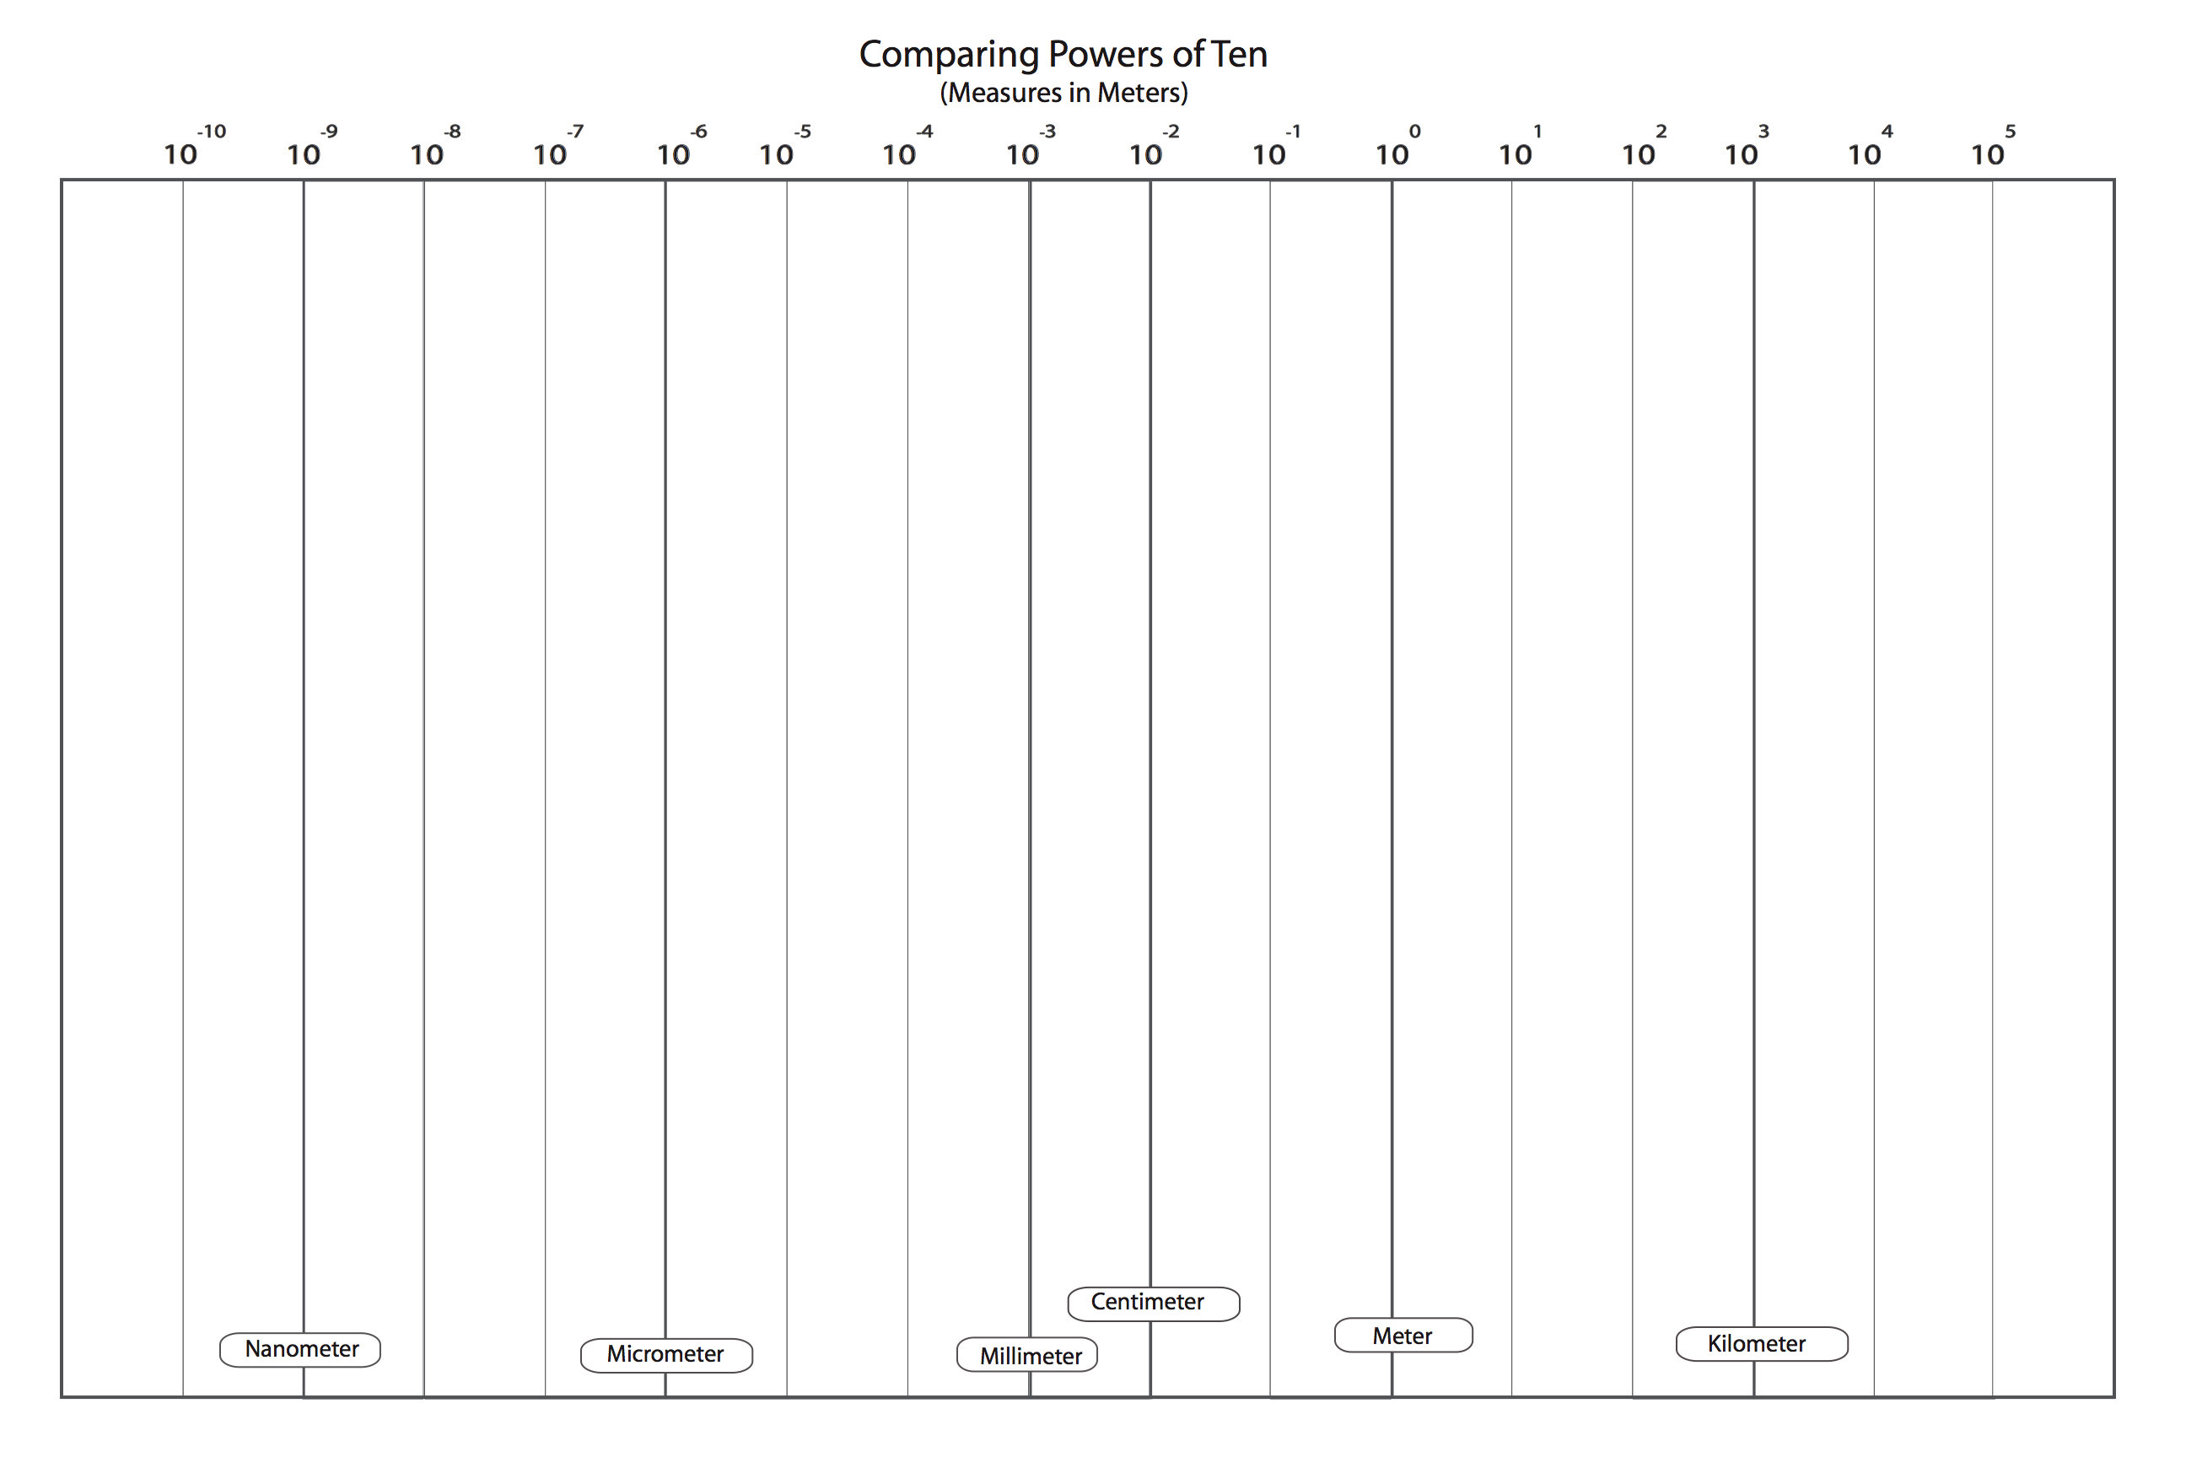

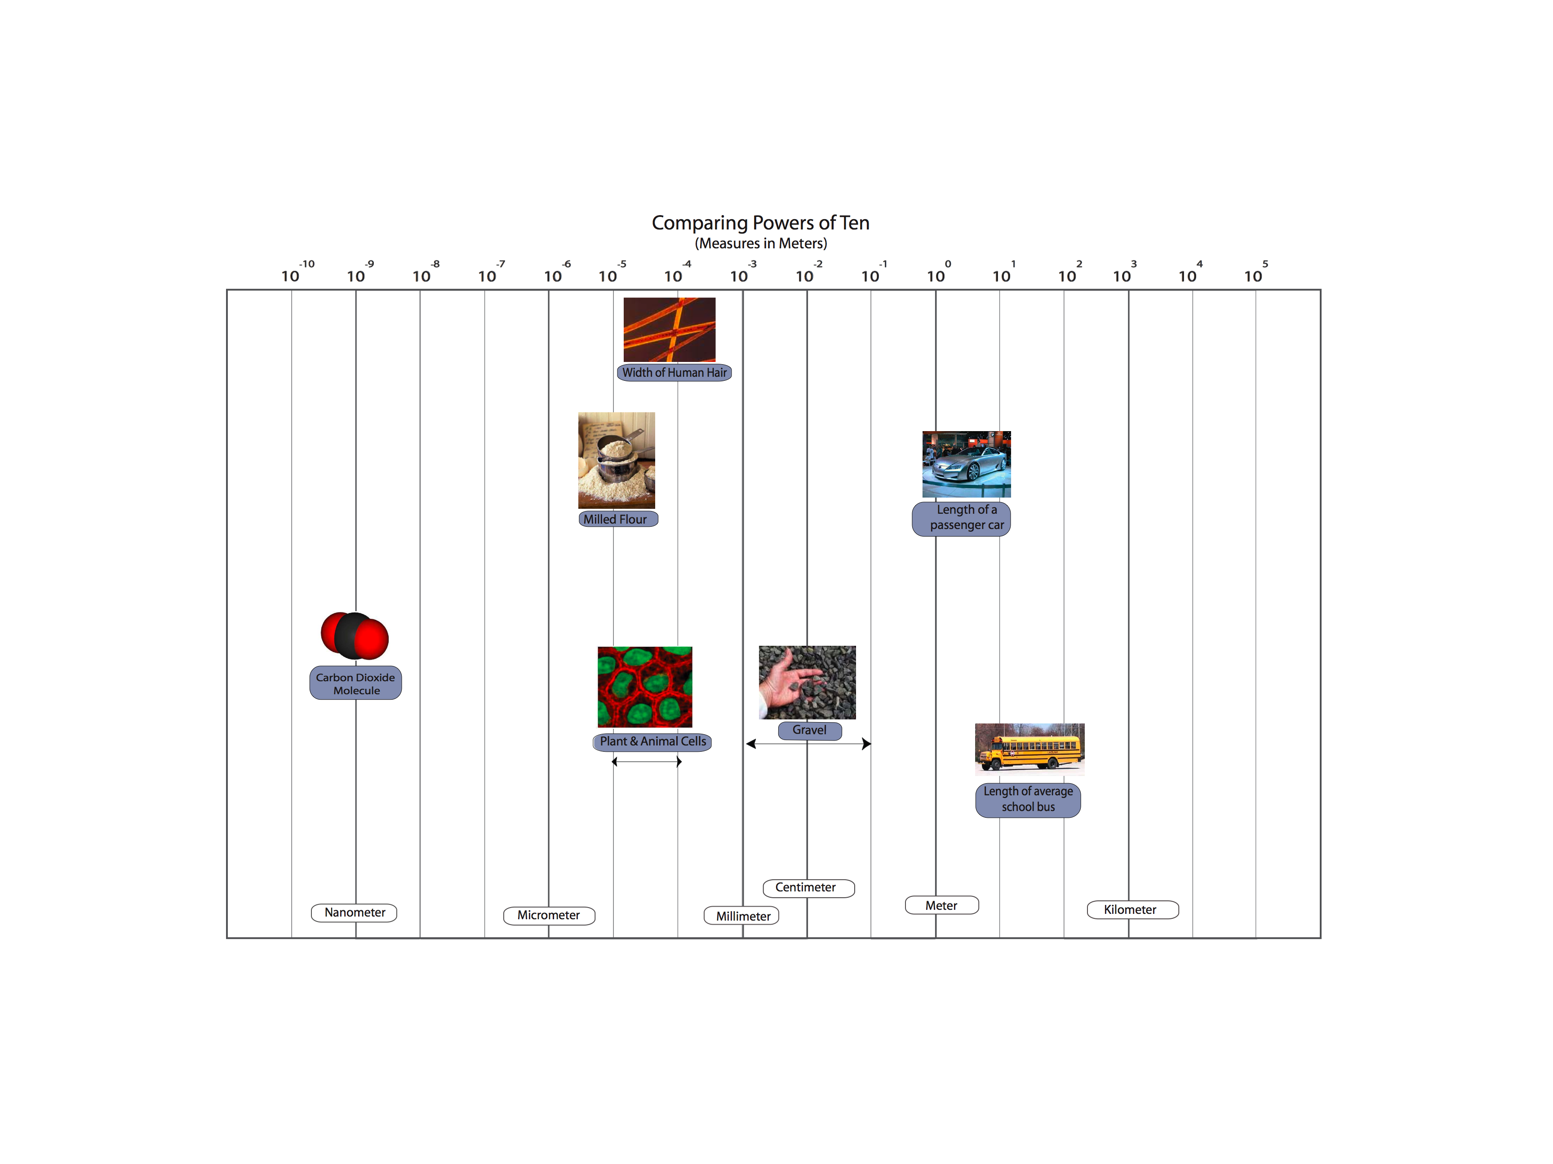
Partial Overhead:
Complete Powers of Ten: Vinyl Class Poster, Student “Answer Keys”, Complete overhead
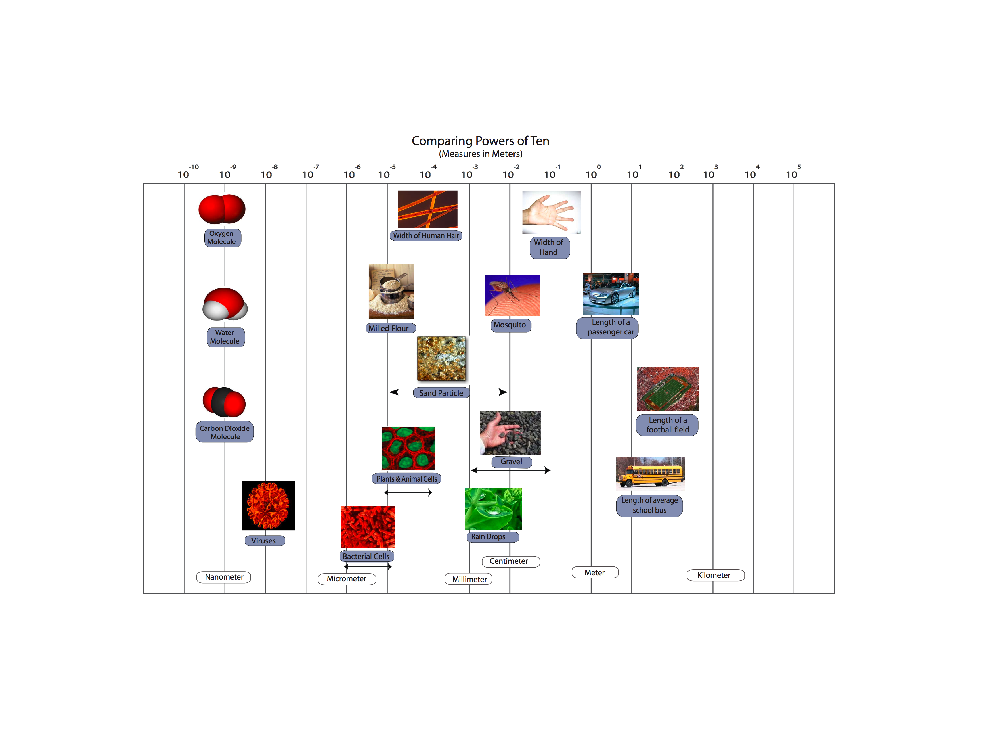

Activity 4: Materials and Needs

General Overview:
Initial Card Sorting Task ~20 minutes
Card Sorting of Needs ~15 minutes
Living organisms and Needs ~15 minutes

Total Time: 50 minutes

Purpose:
This activity is intended to have students think about materials—solid, liquid, and gas—to develop students’ ideas about matter. It provides an opportunity to establish a shared definition of matter in terms of its macroscopic characteristics—that matter takes up space and has mass (or weight for this age level). Students sort cards of different materials/non-materials in several different ways and share how they “categorized” those materials/non-materials. Then the teacher has students sort explicitly in terms of matter/material versus not matter/non-material. This gives the teacher a chance to talk about why “warmth” and “exercise” are not the same as other enablers, such as food, water, air, etc. It also is the first time to explicitly say that “air” is matter. Students then sort the matter cards into solid, liquids and gases. At the end students have a chance to share their ideas about how living organisms are similar and different in the way they use materials and non-materials.

Materials
Student copies of Needs of Living Organisms
10 sets of Enabler Cards for students
1 set of transparency Enabler Cards and/or 1 set of enlarged teacher Enabler Cards
Chart Paper or Blank transparencies (or chalkboard) to record students’ card sorting task

Advance Preparation/ Safety Considerations:
Have copies of Needs of Living Organisms
Gather Enabler Card packets for student groups
Gather Teacher’s transparency Enablers cards and/or enlarged Enabler cards
Gather chart Paper or Blank transparencies (or chalkboard) to record students’ card sorting task

Procedures/Suggestions:

Initial Card Sorting Task ~20 minutes
Distribute a packet of cards to each pair or small group. The packet contains the following materials and needs: bread, fruits/veggies, milk, juice, water, air, warmth, exercise, gasoline, sand, rock. Ask students to sort their cards into 2-3 groups however they would like. Students may sort the cards as 1) solids, liquids, and gases, 2) foods and everything that is not food, 3) things people need to live and things that we don’t need to live, 4) things that were once alive and things that are not alive, 5) matter and things that are not matter, etc. Students get to choose the way they want to sort their cards. Once groups sort their cards into groups, have each group share how they decided to sort the cards. Use the color overhead transparency cards, or an extra set of cardstock cards to demonstrate the sorting of each group. As groups share, record all the different ways that the materials were sorted.

Card Sorting Task #1: Enablers ~15 minutes
Now hold up the following eight cards: bread, fruits/veggies, milk, juice, water, air, warmth, and exercise. Tell students these are things people need to stay alive. Ask students how each “need” helps people stay alive? Then ask which are matter and which are something else.
Matter: bread, fruits/veggies, milk, juice, water, air
Non-matter: warmth, exercise

As students groups the “needs” in terms of matter and non-matter, help the class develop an understanding of matter as anything that takes up space and has mass (weight can be used as an alternative to mass). The key idea at this point is that warmth and exercise are NOT matter, while air IS matter.

At this point the cards can be divided into two groups: Matter and Non-Matter. Before proceeding make sure all students have these grouped in terms of how the class reached consensus. It is possible that air will still be questioned by students.

Divide the matter cards into three groups, using solid, liquid and gas to organize the groups. Don’t tell students that you organized this way. Instead, ask students, “Look at the new way I grouped all the things that were matter. Do you notice a pattern? Can you think of a name that describes each group? Help students generate “solid”, “liquid” and “gas” to describe each type of matter.

Solid: Bread, fruit/veggies
Liquid: Milk, juice, water
Gas: Air

Then, ask students, “Does bread and fruit take up space? Does it weigh something? So is it matter?” Ask the same questions for liquids and gases. STUDENTS MAY NOT AGREE THAT GASES ARE MATTER SO TELL THEM THAT THEY WILL LEARN MORE ABOUT THIS IN THE NEXT LESSONS

NOTE: There are 2 “AIR” Cards

Think-Pair-Share: Needs and Organisms ~15 minutes
Pass out Needs of Living Organisms worksheet. Tell students they are going to answer questions about how living organisms meet their needs. They will first think about and write their ideas to these questions on their own. After 5 minutes, they will share their ideas with a partner, and revise what they have written (if necessary). Then the students will share their responses during a whole class discussion.

Students will first list what they believe each organism needs. Then they classify this list in terms of matter (solid, liquid, gas) and non-matter.

The goal of this exercise is for students to consider both the Matter and Non-matter needs of all organisms. Students should see that all organisms need food, air, and water- these are forms of matter that help organisms grow. Students may not recognize that organisms need gases and they may be challenged by deciding on which things are matter or not matter.



Fruits and Vegetables
Juice

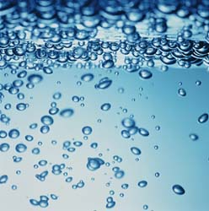


Milk

Air Picture #1


Gasoline

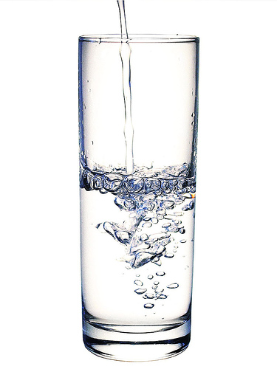
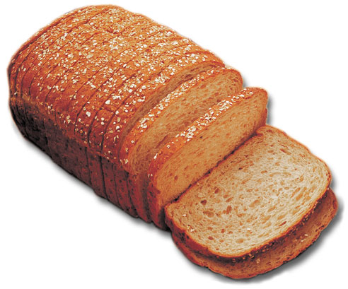
Water
Bread

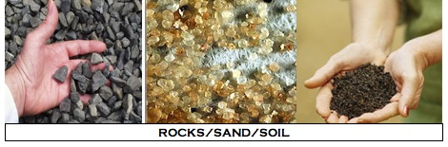

MATTER

NOT MATTER


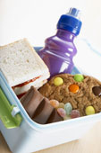
WARMTH
FOOD


EXERCISE


Air Picture #2

Gas
Solid
Liquid
Name: ____________________________________ Date: ________________

NEEDS OF LIVING ORGANISMS

Living organisms include plants, animals, and decomposers. In order to stay alive, organisms must meet their daily needs. Think about what living things need, and then answer the questions below.

PLANTS

1. What things do plants need to live and grow? List all the things that plants need.

__Students may list: Water, soil, sunlight, nutrients, air or carbon dioxide. They may also list things like space, love, shelter, etc.___________________________________ ____________________________________________________________________________________________________________________________________________

Look at your list above. Decide whether each thing is matter or is not matter and then place it where it belongs in the table below.

Matter |  |  | Not Matter
Solid | Liquid | Gas
Soil & nutrients in soil | Water | Air or carbon dioxide and oxygen | Sunlight  Shelter, space

ANIMALS

2. What things do animals (including people) need to live and grow? List all the things that animals need.

__Students may list things like: food, air or oxygen, exercise, vitamins, water _______
__________________________________________________________________________________________________________________________________________________________________________________________________________________

Look at your list above. Decide whether each thing is matter or is not matter and then place it where it belongs in the table below.

Matter |  |  | Not Matter
Solid | Liquid | Gas
Food  Vitamins | Water | Air, Oxygen | Exercise

DECOMPOSERS

3. What things do decomposers need to live and grow? List all the things that decomposers need.

__These students may say a variety of things: Soil, compost, dead things, food, air, shelter or a place to live, sunlight, heat, moisture, etc___________________________ ____________________________________________________________________________________________________________________________________________

Look at your list above. Decide whether each thing is matter or is not matter and then place it where it belongs in the table below.

Matter |  |  | Not Matter
Solid | Liquid | Gas
Soil,  Dead Tree or other dead things  Compost materials  Food | Moisture | Air | Shelter  Heat  Sunlight

NOTE: Answers are just suggestions, not right or wrong answers

Activity 5: Investigating Air as Form of Matter

General Overview:
Generating Matter List ~15 minutes
Air Investigations ~25 minutes
Share and Discuss Observations ~15 minutes
Total Time: 50 minutes

Purpose:
We speak of air as light, "airy," insubstantial”, or even as “nothing”. The topic of air causes difficulties for students because air is a complex mixture of gases that are generally colorless, odorless, and thus undetectable except by indirect means. Many important phenomena, including respiration, photosynthesis, humidity, smells, pollution, and the water cycle, are associated with variations in the mixture of molecules in air. Students must learn to see air and other gases as forms of matter like liquids and solids, with all the characteristics of matter in general: -- air is made of molecules -- air takes up space – air has mass or weight. The next two activities focus specifically on helping students understand gases as a form of matter.

Activity 5 includes observable investigations that show air has the same macroscopic characteristics of solids and liquids—that air takes up space and has mass. These investigations can be conducted as demonstrations by the teacher and/or students or as rotating lab stations. In order to focus the class discussions around the investigations (and to ensure students get the most out of each investigation) we recommend to conduct whole group demonstrations, however, some can be completed by all the students (e.g., blowing up balloon, alka seltzer and balloon).

The point of today’s activity is to talk about macroscopic observations that tell us air takes up space and has mass, and to consider how air my contribute to weight loss or weight gain.

The following activity goes into more detail about what makes up air (air as a mixture) and how agents change the air around them.

Materials
Student copies My Observations of Air
1 set of overhead transparency Enabler Cards and/or 1 set of enlarged Enabler Cards
Chart Paper or Blank transparencies (or chalkboard) to record students’ Matter-Not Matter List Investigation supplies:
- Aquarium or large container filled with water
- 2-3 clear plastic party cups
- 1 tissue
- Lots of balloons
- 1 gym ball
- 1 ball pump or small air compressor
- Scale sensitive to 0.1g or 0.01g (the more sensitive the better)
- Fizz keeper
- Empty soda bottle
- Alka seltzers
- Wide mouth juice or water bottles
Advance Preparation/ Safety Considerations:
Gather transparency Enabler cards and/or enlarged Enabler cards
Gather chart Paper or Blank transparencies (or chalkboard)
Have student worksheets My Observations of Air

Investigations: Investigations 4, 5, 6 and 7 ahead time to check that your scale is sensitive enough to detect a difference in mass or weight. Also check the alka seltzer demonstrations for time it takes to dissolve and to know how much pressure will build up inside the balloon or container.

Procedures/Suggestions:

Generating Matter List ~15 minutes
Show students the three groups of card from Activity 6 that show solids, liquids and gases. Remind students that they were talking about things that are and are not matter. Ask students if they remember how we define or describe matter (material that takes up space and has weight/mass). Write this on the front board or overhead. Then take out the Matter overhead transparency or use chart paper to record students’ ideas about things that are and are not matter.

First list things in the matter column. Then ask students about things that are NOT matter and list their ideas. There may be overlap between the columns. If overlap occurs, circle or highlight those items.

The table below was a list generated by a 4th/5th grade class and may show similar items that students will share during this activity. Note that students were still confused about whether things like air, gases, heat and clouds were matter.

MATTER | NOT MATTER
Furniture (Bed)  Plants  Building, School  Refrigerator  Anchor  Air  Heat  Living things  Water  Animals  Body parts, People  Boulders, rocks  Books  Machines  Walls  Metals  Clouds  Playground | Light  Chemical gases  Carbon dioxide  Shadows  Sound  Electricity  Heat  Clouds  Germs  Gravity  Imagination  Air  Ants  Water vapor

Tell students that today they are going to look closer at gases and decide if it meets the definition for matter. Does gas take up space? Does gas have mass?

Air Investigations ~25 minutes
There are several possible ways to conduct the following investigations. The teacher can gather students around the front of the room and demonstrate each one, while students record observations OR students can rotate through several stations, conducting the investigations and recording observations, then sharing with the whole group later. We recommend to conduct mostly demonstrations in order to focus students attention and discussion on individual investigations. The decision also depends on available supplies.

Pass out My Observations of Air to each student.

Proceed with the investigations and make sure to focus discussions of the investigations on what it demonstrations- that air takes up space and has mass (which at the macroscopic scale is similar to solids and liquids).

Investigation #1: Move Air Under Water

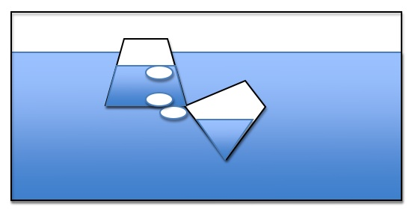
This investigation is a simple demonstration to transfer air between two submerged cups. Fill an aquarium or large, transparent container with water. Use 2 small plastic cups for the demonstration. As you submerged the cups, make sure one fills with water, while the other captures mostly air. Place the cup with the air tilted underneath the cup with water and slowly move the air back-air-forth between the cups. Ask students if the air or air bubbles take up space.

Investigation #2: Keep a Napkin Dry Under Water


This investigation is a simple investigation to show that a napkin can stay dry under water. Take a tissue/napkin into the bottom of a clear cup. Fill an aquarium or large container with water. Flip the cup so that it is facing down. Carefully submerged the cup trapping air inside the cup as it enters the water. Be careful not to tilt the cup because this may release water. Slowly bring the cup out of the water. Let students fill the napkin to verify that it is still dry. Ask students if this shows that air takes up space.

Investigation #3: Blow-Up a Balloon

Tell students to blow up a balloon or blow up a balloon to demonstrate. Ask students what is inside the balloon. Ask students if the balloon shows that air takes up space.

Ask students to take a deep breath. What fills up their lungs? Does their chest expand? Is the air inside their lungs taking up space?


Investigation #4: Ball and Pump

The class may have a set of recess balls or you may need to borrow from the gym teacher or bring from home (MSU may supply if needed). Use a digital scale sensitive to 0.01g or 0.1g. You may need to borrow this scale from the middle or high school. Weigh an athletic ball on the scale and record the weight. Then use a ball pump to air up the ball. Make sure to get as much compressed air inside as possible. Then re-weigh the ball. Ask students, does this show that air has mass/weight? Make sure to weigh the ball carefully and to use the same ball for before and after since different amounts of plastic/rubber can change weight dramatically.

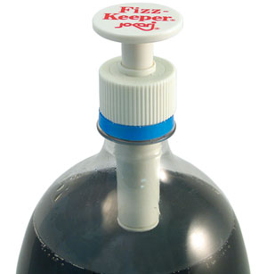

Investigation #5: Pump Air into a soda bottle

Use a two-liter soda bottle emptied and clean. Screw on the fizz pump. This pump allows you to pump air into the soda bottle. Tell students to watch as the soda bottle pumps up. You may also be able to weigh before and after if you have a sensitive scale, but the air will not be as dense as the gym ball demo so the difference may not be detectable. Students will observe the soda bottle becoming more rigid and when the pump is removed they will hear a “whoosh” of air.

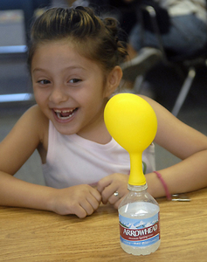
Investigation #6: Alka Seltzers and Balloon

This investigation uses alka seltzers and water, which when mixed, give off carbon dioxide gas. Use a soda or water bottle filled with an inch of water. Drop two alka seltzers into the water and quickly cover the top with a balloon. If the balloon is too small it may pop, so consider using larger balloons made of thicker material. The CO₂ gas will collect in the balloon. Ask students, what is filling the balloon? Does air take up space?

Investigation #7: Alka Seltzers and Scale

There are several ways to conduct this lab activity, but it is probably best done as a demonstration (for elementary students).

You will need an empty wide-mouth soda, water, or juice plastic container. Fill the container with an inch of water. Place the lid on top of the container. Then place 2 alka seltzer tablets on top of the lid. Weigh with a scale sensitive to at least 0.1g (0.01g is even better). Make sure all students see the weight.

Leave the bottle on the scale. Unscrew the lid and place the 2 alka-seltzer tablets inside the lid. Quickly turn the lid over (dropping the tablets in the water and screw lid back on bottle, allowing the tablets to drop in the water without letting too much air escape. As the tablets decrease, have students note the mass is still the same even though the bottle is expanding with air. Point out that the size of the tablet is decreasing, but air is increasing. The mass stays the same, so there is the same amount of “stuff” in the bottle, it’s just changing from solid to gas. Then unscrew the lid slowly to release the air. Watch the mass goes down as air escapes. Ask students, does the air (that came from the solid) have mass? Did it take up space?

Alternative: Suspension system

You will need an empty wide-mouth soda, water, or juice plastic container. Fill the container with an inch of water. Place two alka seltzer tablets in a mesh square cloth. Tie the cloth with thin string (such as fishing line). Dangling the mesh inside the plastic container just below the opening. Leave part of the string outside the container and screw on the plastic lid. Weigh the container on a scale sensitive to 0.01g (0.01g is even better).

Then turn the container upside down on the scale and allow the water to react with the alka seltzer. The bottle needs to be able to balance upside down so a wide mouth container may work best. Have students note that the mass is still the same. Point out that the size of the tablet is decreasing, but the air is increasing. The mass stays the same, so there is the same amount of “stuff” in the bottle, it’s just changing from solid to gas. Then flip the bottle over and unscrew the lid slowly to release the air. Watch the mass goes down as air escapes. Ask students, does the air (that came from the solid) have mass? Did it take up space?

NOTE: IT IS VERY IMPORTANT TO POINT OUT THAT THE SOLID TABLETS ARE GETTING SMALLER AND GAS IS INCREASING. SINCE THE MASS STAYS THE SAME STUDENTS MIGHT CONCLUDE THAT GAS DOES NOT HAVE MASS. THEY NEED TO SEE THAT THE MASS STAYS THE SAME BECAUSE THERE IS THE SAME AMOUNT OF STUFF INSIDE CONTAINER (CHANGING FROM SOLID TO GAS). ALSO, THE RELEASE OF AIR SHOULD CAUSE THE MASS TO GO DOWN INDICATING THE AIR DOES HAVE WEIGHT.
Name: __________________________________________ Date: ________________

My Observations of Air
In the table below, write down what you observe during each investigation. Describe as much as possible, what you see happening in the investigation.

Investigation #1 and 2  Air was in bubbles that moved backed and forth between the cup  Air created space that kept the napkin dry | Investigation #3  The balloon got bigger when more air was blown inside it. It changed size.
Investigation #4  The ball gets bigger when air is pumped inside. The ball weighed more with air inside. | Investigation #5  The air made the bottle hard; it got harder to pump air inside when it was getting full; there was a “whoosh” sound when the cap was taken off
Investigation #6  Alka seltzers made lots of air bubbles; the balloon got bigger and bigger; the alka seltzers got smaller and smaller | Investigation #7  The tablets made lots of bubbles and the soda bottle become very hard. It weighed the same even though it was getting harder. It weighed less when the cap was removed.

Questions:

- Is air matter? Why or why not?
_Air is matter because it takes up space and has weight like solid and liquids. We can’t see air, but we can see things that let us know air is there and it is matter. ___________ ________________________________________________________________________________________________________________________________________________________________________________________________________________________________________________________________________________________

- Do you think air can cause something to gain weight? Why or why not?
__The air caused the ball to gain weight, so air can cause things to gain weight. It is matter and has weight. ___________________________________________________
________________________________________________________________________________________________________________________________________________________________________________________________________________________________________________________________________________________

- Do you think air can cause something to lose weight? Why or why not?
___ The air caused the soda bottle to lose weight, so air can cause things to lose weight. It is matter and has weight. _________________________________________
________________________________________________________________________________________________________________________________________________________________________________________________________________________________________________________________________________________

Activity 6: What is Energy? (Forms of Energy)

Overview:
Introduction/Students’ PK on Energy ~10 minutes
Reading about Energy Forms with Discussion ~25 minutes
How Ideas Have Changed ~10 minutes

Total time: 45 minutes

Purpose:
The word energy has both colloquial uses and scientific uses. The way ‘energy’ is used in daily life is very different from the scientific meaning of energy. The colloquial use of energy strongly influences students’ conceptions, thus causing many misconceptions and confusions about energy in science. Based on their daily life, students have constructed a lot of ideas about energy. In their mind, energy is mostly associated with movement, activities, or life. Energy can also be a kind of semi-material which can appear and disappear mysteriously or can be converted from or into matter. All these ideas conflict with the scientific meaning of energy. In science, energy is an abstract quantity associated with certain evidences, such as light, sound, foods/fuels, etc. It cannot be converted from or into matter except in nuclear reactions. This activity allows students to share their ideas about energy and introduces students to Energy Forms. A list of energy forms is introduced with explanation about how to identify each energy form based on its evidence. Energy forms are defined differently in different media or textbooks. For example, some textbooks address sound energy, which is also a type of motion energy. Solar energy is also light energy. Some different ways of defining energy forms are also addressed in this activity. As students read about different forms of energy, they share their ideas about where they have observed these different forms. The teacher records the students’ ideas. Then the teacher shows students a class poster that they can continue to use as they learn more about energy. At the end, students engage in a quickwrite about how their ideas have changed after reading about forms of energy.

Materials:
Student copies of My Ideas about Energy
Student copies of reading Energy Forms
Overhead to document students’ example of energy forms

Advance Prep:
- Gather copies of My Ideas about Energy
- Gather copies of Energy Forms (a reading to be collected and re-used)

Procedures:

Introduction 10 minutes
Pass out My Ideas about Energy. Ask students: what is energy? What does that word mean to you? Take about five minutes for brainstorming and then have students write down their initial ideas about energy on the My Ideas about Energy handout.

Reading: Energy Forms 25 minutes
Pass out Energy Forms to students. You will have 1 class set, so these handouts should be collected by the teacher for future use. The students will read through Energy Forms. As students read, stop the class and check student comprehension by asking the students to name other examples of that form of energy. Use the overhead transparency Examples of Energy Forms to record students’ ideas.

After the class completes the reading, take about 10 minutes to explain the following two points to the students:
- Energy is really hard to define, even for scientists. Forms of energy give us a way of talking about different types of energy, and how energy changes even if energy cannot be “seen”. But energy forms helps us identify energy.
- There is a difference between matter and energy: unlike matter, energy does not have mass and does not take up space; it is not made of molecules. Matter cannot become energy and energy cannot become matter.
Allow students to share something new they learned about in the reading.

How Ideas Have Changed 10 Minutes
Give students a few minutes to write down something new they learned in the reading, or to explain how their ideas have changed. Also let them write 1-2 questions they still have about energy.

If time, allow students to share their energy questions, and consider recording these on a class overhead or chart paper to revisit later in the unit.
Name: ___________________________________________ Date: ____________

My Ideas About Energy

We use the word “energy” all the time. But what does this word mean? Think about what the word “energy” means to you. Use the space below to write about your ideas.
__Energy helps you run and stay awake. When you you’re your energy, you feel tired and need to rest. We get energy from our food and the stuff we eat and drink. ________________________________________________________________________________________________________________________________________________________________________________________________________________________________________________________________________________________

Now, let’s read about energy.

You have just read about different forms of energy. How have your ideas about energy changed? Did you learn something new or different from what you wrote above?
___There are different types of energy and energy changes forms. There is light energy, motion energy, chemical energy, electrical energy, and heat. _______________ ________________________________________________________________________________________________________________________________________________________________________________________________________________________________________________________________________________________

Do you have any questions about energy or forms of energy?

Question 1: ____________________________________________________________
______________________________________________________________________
Question 2: ____________________________________________________________
______________________________________________________________________
Energy Forms

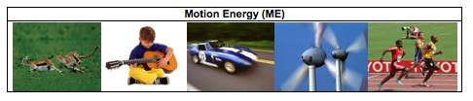Look around you. Many things are moving. They are in motion. Clouds drift across the sky. Leaves fall from the trees. A car speeds by. Birds fly. Whenever there is motion, we “see” motion energy. Holland is using wind energy, because it is clean and does not cause global warming. Wind energy is a kind of motion energy, because wind is moving air. Sound has energy. Sound energy is a special kind of motion energy. It is caused by vibration – the back and forth motion of air molecules.

Can you think of other examples of motion energy that you see every day?

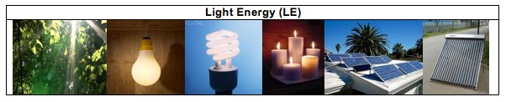
We use light every day. We use it to see things. Without light, our lives would be very difficult. Light helps our life more than just to help us see things. Sunlight helps plants grow. Doctors use special light to perform surgery. Light has light energy. When the lamp is turned on, it gives off light energy. When a candle is burning, the flame gives off light energy.

The light energy from sun is sometimes called solar energy. The sun is a giant ball of burning gas. It gives off light all the time. It will keep shining and giving us energy for millions of years. Plants capture and use light energy to make their own food. Scientists have also invented ways to use light energy. Solar collectors on house roofs can capture light energy and use it to heat the water in the house. Solar cells on cars and house roofs can also capture light energy and use it to make electricity.

Can you think of other examples of light energy that you see every day?

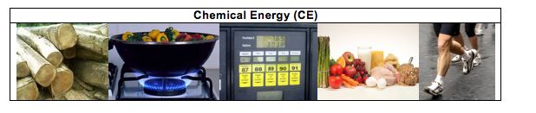Chemical energy is the energy stored in some special materials. Foods, fuels and body parts of all living things are made of materials that contain chemical energy.

All living things are made of cells. The food we eat has chemical energy that helps power our cells. The chemical energy in food helps cells do their jobs in our bodies. Chemical energy helps muscles cells work when we run. It helps brain cells work when we think. Chemical is very important for our bodies.

Like food, fossil fuels are another special material with chemical energy. Fossil fuels come from plants and animals living millions of years ago. The plant and animals were buried underground. Over long periods of time, they turned into fossil fuels. There are three types of fossil fuels – oil, natural gas, and coal. We use fossil fuels everyday. Our cars are powered by gasoline. We use methane for cooking. We use propane to barbecue and heat homes.

Can you think of more examples of things that have chemical energy?
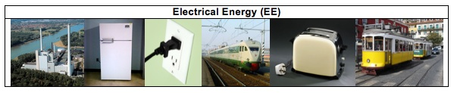
People use electricity everyday. Your family uses many electrical appliances at home. You may watch TV after dinner. Your parents may use a laptop for work. You may use a toaster to toast bread or use a microwave oven to warm your food. To make these machines work, you plug them into an outlet on the wall. What the machines get from the outlet is electricity.

We not only use electricity to power our homes, school, or other buildings, we also use electricity for transportation. Electric trains or subway trains have engines that run on electricity. These engines get electricity through a metal rail under the train, or from wires at the top of the train.

Electricity has electrical energy. Electricity is generated by different types of power plants. Wind power plants use wind to generate electricity. Nuclear power plants split uranium atoms to make electricity. Hydropower plants use the energy of moving water to make electricity. Fossil fuel fired power plants burn fossil fuels to generate electricity. In the United States, about 51% of our electricity comes from burning coal.

Do you know where your electricity comes from? What type of power plant sends electrical energy to your home?

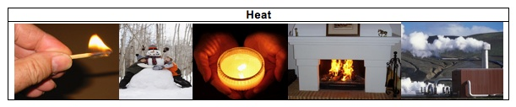
When you run a car for a while, the front of the car becomes very hot. When a flame from a candle or a campfire is burning, you can feel the warmth. When you are exercising, you also feel very hot. Even when you are playing outside on a cold winter day, your body stays warm. Your body temperature always stays close to 98.6°. In all these events, heat or heat energy is released. Geothermal energy is the heat within the earth. Geothermal power plants use the steam or hot water from the earth to generate electricity. Heat is a special form of energy. Whenever changes happen, heat is always given off to the outside of the system. Unlike light energy and chemical energy, heat cannot be “caught” by any living organism to help their body function or to help them move.

Examples of Forms of Energy

MOTION | LIGHT | CHEMICAL | ELECTRICAL | HEAT

Activity 7: How Does Energy Change?
Note: This activity can be completed in conjunction with Activity 6.

Overview:
Review different forms of energy ~ 5 minutes
Introduce Process Tool ~ 10 minutes
Transformations and Process tool ~ 30 minutes

Total time: 45 minutes

Purpose:
Based on their life experiences, students tend to hold the idea that energy can be created or destroyed. For example, energy can be created by sleeping or rest. Energy is always used up and needs to be constantly replenished. These ideas conflict with the two fundamental energy principles in science: energy conservation (i.e., energy is always conserved) and energy degradation (i.e., heat is always released). In this activity, these two scientific principles are introduced by the Process Tool with a focus on energy conservation. The idea is that whenever there is energy input (represented by the incoming wavy arrow), there is always energy output (represented by the outgoing wavy arrow), so energy cannot be created or destroyed. Also, the energy output always contains heat, so not all energy can be used to do useful work or be passed on from one organism to another.

This activity intends to introduce the process tool by the simpler events of machines working. Students will observe how several scientific toys work and figure out how energy transforms in each event. These events are much easier than biological or chemical events since they do not involve matter transformation. Students are expected to understand energy transformation in this activity, but they will eventually use the tool to make sense of both matter and energy transformations in biological changes.

Materials:
Student copies of How Can Machines Work?
Large Process Tool- use for each machine (toy)
Powerpoint or transparencies: How Can machines work.ppt
Energy “Toys” and Lamp

Advance Prep:
- Make copies of student handouts if not provided by MSU
- Make sure process tool is ready to use or consider using powerpoint/overheads of the process tools
- Gather Energy toys

Procedures:

Introduction 5 minutes
Have students review the different forms of energy. Tell students that today they are going to learn how energy changes different forms. Point to the Energy Poster and explain that today they will only talk about four forms of energy: light, motion, heat, and electrical.

Introduce Process Tool 10 minutes
Explain to students that energy is always conserved, even as it changes forms. We can always trace how energy is conserved by looking at how energy changes from one form to other forms. Tell students that they are going to do an activity where they show how energy is conserved by tracing how it changes in different types of machines. Show students the process tool and tell them this tool is going to help them show how energy is conserved even when energy is changing forms. Use an example (e.g., lamp lighting up) to model how to use the process tool to explain energy transformation in processes. Use the large-size process tool, which is made of magnetic board and labels. Show that energy originally starts as Electrical Energy and changes to Light Energy and Heat.

Use Process Tool to Explain How Machines work 30 minutes
Divide students into groups or partners and pass out How Machines Work. Explain that they are going to use the tools to show how energy changes in different machines. Use three toys to demonstrate four events: radiometer spinning under light, solar car running under sunlight, solar car running with battery, and motion flashlight lightening by squeezing the handle. On the student worksheet, How Can Machines Work?, there are questions about the four events. Students observe the demonstration and work together to figure out the energy input and output for each event. They then use this information to finish the blanks and questions on the worksheets. This will take about 15 minutes.

Allow time for the class to review each energy machine. Have student groups present their “process diagram” for the different energy machines. Allow students to use the class process tool to show their diagrams to classmates. As students share their ideas, ask the other students in class if they agree with the energy forms and energy transformations that occur. Ask them how they know energy is conserved, and ask them if the event shows energy degradation.

Allow time to discuss the 5th question on the students’ handout: What patterns do you see. Students should note at least 2 patterns that relate to energy is conserved by changing forms and heat is always released.

NOTES TO TEACHER- The notes below go into much greater detail about energy than is expected of elementary students. They are intended to be useful information for the teacher.

1. Challenges in teaching about energy
Scientific and informal uses of the word “energy.” Scientists sometimes use everyday words to label specific concepts they developed. Energy is one such word. We use the word energy in our everyday language, but energy, as a science word, has a specific meaning. Students hear their mothers remind them to drink enough water, because water will give them “energy.” Students may also feel that they get “energy” from vitamins, sleep, exercise, stimulants, etc.. None of these provide energy in the scientific sense.

Distinguishing energy from matter. We commonly suggest that some substances (e.g., glucose, ATP, gasoline) are energy, or that matter can be transformed into energy (e.g., “the wood burned up to produce heat and light”). THIS DOES NOT HAPPEN EXCEPT IN NUCLEAR REACTIONS. This is why it is important to keep matter and energy arrows separate in the process tool.

Defining and measuring energy. Unlike matter, energy cannot be seen even from the most advanced microscopes. You can hold a grind of sand in your hand, but cannot hold energy. You have learned how to identify energy by evidence. But, what is energy? What is the definition of energy? If you ask this question to scientists, they will give you many different answers. They will also tell you that memorizing the definition of energy is not important. So, what do scientists know about energy? Why is the concept of energy useful for us? Although we cannot see energy, there is always evidence of energy. In this lesson, we will learn how to identify the six most basic energy forms. Scientists can measure energy. They can measure the amount of energy you gained from a glass of milk. They can measure the amount of energy used to move a car from the city you live in to New York. They can also measure the amount of energy that operates a light bulb for one hour.

2. About the two energy principles. When scientists measure energy, they find two laws of energy transformation.

- Energy Conservation: The total amount of energy always stays the same.
Energy cannot be created or destroyed, it always transforms from one form to other forms. Energy always transforms. It cannot be converted into matter.

- Energy Degradation: The amount of useful energy always decreases, because heat is always released.
Whenever energy transforms, there is always heat released. Heat energy cannot be captured by plants and animals. So, although the total amount of energy conserves, the amount of useful energy always decreases.

The next series of activities focus on energy forms, especially chemical energy. It is important to understand that some materials can be used as energy sources, because they contain high-energy bonds. In the carbon cycle, there are two types of high-energy bonds: C-C bonds and C-H bonds. The materials that contain C-C and C-H bonds are organic materials, which can be used as energy sources for human living and activities. When these materials react with oxygen, energy is released. Materials with O-H or C-O bonds do not have the chemical energy necessary for life-sustaining processes or combustion. While you do not need students to talk about this in this lesson, you may have them note the types of bonds in the air molecules they built because they will need to compare air molecules to food and fuel molecules in the next lessons.
Name:____________________________________________ Hour:___________

How can machines work?

In this activity, you will show how energy changes forms. The wavy arrow going into the box represents the energy input to the machines. The wavy arrow coming out of the box represents the energy output from the machines. As you look at each machine, decide what FORM of energy comes in and what FORM of energy comes out. Choose from among the four forms:

Light Motion Electrical Heat

1. Radiometer: The radiometer is a light-bulb shaped device with a small weather vane in the middle of it. Place the radiometer under a lamp or sunlight and observe what happens when the light shines on it. Think about what happens inside the radiometer. Please fill out the energy input and energy output in the blanks below. You may not need all the blanks.
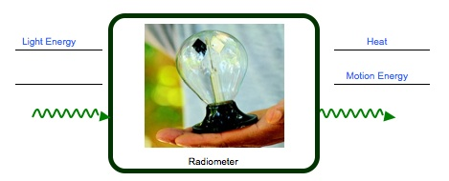

2. Solar Car #1: The solar car has a switch at the bottom. It can either run on battery or use solar cells. Put the switch on “solar”. Observe what happens when the car runs on solar cells. Please fill out the energy input and energy output in the blanks below. You may not need all the blanks.
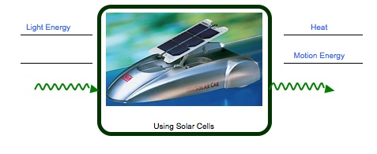
3. Solar car #2: Put the switch on “battery”. Observe what happens when the car uses the battery. What is the energy input? What is the energy output? Fill out the energy input and energy output in the blanks below. You may not need all the blanks.

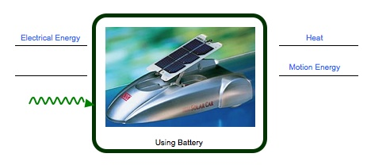
Chemical Energy
4. The Flashlight: In order to make the flashlight work, you will need to squeeze the handle back-and-forth. Observe what happens when you squeeze and release the handle. What is the energy input? What is the energy output? Fill out the energy input and energy output in the blanks below. You may not need all the blanks.

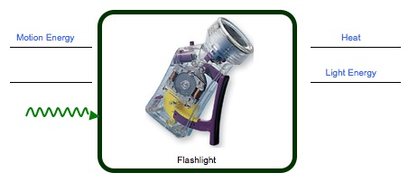
5. The four events are all show energy changing from one form to another. What patterns do you see in your four diagrams?
There are two patterns:
1) Energy cannot be created or destroyed. It only transforms from one form of energy to other forms of energy.
2) Heat is always released.

Activity 8: Energy and Fuels

Overview:
Review Forms of Energy ~5 minutes
Candle Demonstration ~25 minutes
Summary Questions & Discussion ~20 minutes

TOTAL TIME: 50 minutes

Purpose:
The purpose of this activity is to use combustion of a candle as an example to introduce the process tool with both matter transformation and energy transformation. Activity 8 introduces the process tool in a way that only discusses energy transformation. This activity will add matter transformation to the process tool.

Today’s activity focuses on two common misconceptions about matter and energy. In science, energy transformation should be clearly distinguished from matter transformation. (Matter-energy conversion only happens in nuclear reactions.) So, in the process tool, energy is represented by the wavy arrows and matter is represented by the straight arrows. The rule is that wavy arrows cannot change into or from straight arrows. Students observe the candle burning and think about the materials that the candle needs to burn (wax, oxygen) and what is given off (water and carbon dioxide). They learn that the solid wax melts to become liquid wax but that it eventually is changed in to gases that change the mixture of air. Then students talk about how energy changes. They learn that the wax in the candle has chemical energy that eventually becomes heat and light.

Materials:
Student copies of Burning A Candle (with observation sheet & process tool diagrams)
Large-Size Process Tool
Candle
Lighter
Large glass container

Advance Prep:
Make copies of student handouts if not provided by MSU
Make sure Large-size process tool is ready for use

Procedures:

Review Forms of Energy ~5 minutes
Review the 5 key forms of energy from previous lessons. In particular, review what students learned about chemical energy. Where is it found? (foods, fuels, all living things)

Burning Candle ~10 minutes
Pass out Burning A Candle worksheet. Ask students if they have ever watched a candle burn. Ask them to share what they have seen. Ask students what happens to the candle if it burns for a long time (it gets shorter and shorter until the wax is gone)
Tell students today that they are going to watch a candle burn. But this time they are going to think about 2 things: 1) what is happening to the materials when the candle burns, and 2) what happens to the energy.

MATERIALS/MATTER

Tell students to first think about the materials. Ask students: what materials does the flame need in order to keep burning? Students may answer wax, air, etc. Then invert a glass container (beaker) over the flame. After a few minutes, the flame goes out. After students finish their observation, ask them to record their observations of what happens on their Burning a Candle worksheet. Ask them to think about what happens to the wax and if anything is happening to the gases in the air around the flame.

In order to talk about the materials you will need to walk students through the burning process. First the materials start out as a solid wax, the solid wax melts to become liquid wax. Over time both the solid and liquid wax get shorter. Where does the wax go? Students are expected to identify “macroscopically” the reactants and products involved in burning. In particular, gaseous matter including water vapor and oxygen should be identified.

Repeat the demonstration several times, focusing students on what is happening to the solid and liquid wax, then what happens to the air. At this point students should know clearly that burning needs fuel (wax) and oxygen to burn—these are the matter inputs. USE THE PROCESS TOOL TO DOCUMENT THAT OXYGEN GAS and SOLID WAX go into the burning process.

Then take a cold watch glass and hold it 15-20cm above the flame. Make sure that the glass is not put too close to the flame, or the water drops will not be observed due to the heat. After a few minutes, water drops should condense on the glass. After students finish their observation, ask them to record their observations and answer the questions in the relevant column of the table.

At this point you can identify water as a material product of burning using the process tool. The water is actually a gas so tell students water vapor is given off. Then tell students that there is another gas given off that we cannot see—carbon dioxide. POINT OUT THAT THE SOLID WAX AND GAS OXYGEN EVENTUALLY BECOME TWO GASES.

Ask students again, what would happen if this candle burned a long time? As the solid and liquid wax gets less and less, where do the materials go?

ENERGY

Now tell students to pay careful attention to what happens to the energy. Ask students: what kind of energy is in the wax? Students may not understand chemical energy well, but could reach this by process of deduction. Use the process tool to show that chemical energy is the energy input.

Ask students what forms of energy are observed when the candle burns? (heat and light). Complete the process tool.

Summary questions and Discussion ~20 minutes
Make sure students complete the process tool on their own handouts and then give students about 10 minutes to answer the summary questions

Spend the last 10 minutes of class discussion the questions.

Key Ideas:

Emphasize that burning a candle shows that the materials that make up the solid wax eventually change to gas materials, and that burning actually changes the mixture of air—less oxygen and more water vapor and carbon dioxide.

Also review the idea that fuels are special materials with chemical energy and that burning them gives us other forms of energy that we can use.

If time, consider connecting back to powers of ten—tell them that sometimes things look a certain way at the visible scale, but things could be happening at the smaller or larger scales.

Name: ________________________________________ Date: _________________

Burning a Candle

Record your observations of the candle in the table below.

What happens to materials as the candle burns? | What happens to the energy as the candle burns.
Wax melts- it changes from solid to liquid; the candle gets shorter if it burns for a long time  Oxygen is used by flame  Water vapor is given off by flame | Light energy and heat are given off by the candle.

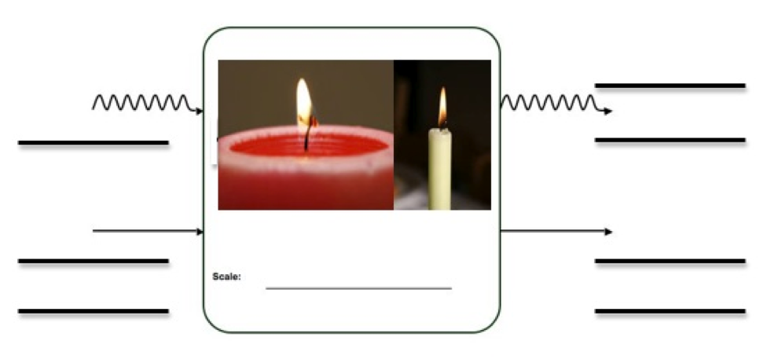
Chemical Energy
Oxygen
Light Energy
Heat
Water/water vapor
Carbon dioxide or other gases/air
Solid/Liquid Wax
Questions

1. The candle is made of solid and slowly turns to liquid as it melts. After a long time, the candle will get shorter and all the solid and liquid will look like it is gone. What do you think happens to the stuff that made up the candle?

___The wax changes to gases and goes into the air.____________________________ __________________________________________________________________________________________________________________________________________________________________________________________________________________

- Wood and wax can burn, but water, sand, and stone cannot burn. Some materials are called fuels. Fuels can burn, which means energy must come from fuels. What type of energy do fuels have?

___Fuels have chemical energy ____________________________________________
______________________________________________________________________

- How does the energy change as the fuel burns?

______The chemical energy in the wax changes to light energy and heat. ___________
__________________________________________________________________________________________________________________________________________________________________________________________________________________

Activity 9: Air is a Mixture

General Overview:
Review of Investigations of Air and Candle ~10 minutes
Teacher reading of Air is a mixture ~10 minutes
Student work How Does Air Change? ~15 minutes
Discussion How Does Air Change? ~15 minutes

Estimated Time: 50 minutes

Purpose:
This lesson is designed to get students thinking about air as a mixture. Students have talked about different forms of matter and conducted simple investigations to show that air has similar macroscopic characteristics of matter—that it takes up space and has mass. They have also learned how matter changes when a candle burns. Students will likely still consider air as different from solids and liquids, but at this age level it is important that air become usable to students when they trace materials. This activity teaches students that air is a mixture of many different gases. Students brainstorm how agents—organisms and flames—change the mixtures of air around them.

Materials:
Student copies of Air is a Mixture Reading (collect and re-use reading)
Student Copies of How Is Air Changed

Advance Preparation:
- Gather copies of Air is a Mixture
- Gather Copies of How is Air Changed

Procedures:

Review Investigations ~10 minutes
In Activity 5 students conducted or observed several investigations to show that air has similar macroscopic characteristics as solids and liquids. For the first 10 minutes of class review what students observed and what they concluded about air—is it matter or not matter? Also review what students learned in Activity 8 about how flames change matter.

Tell students that at the visible, macroscopic scale air seems like “nothing”. There are macroscopic characteristics that tell us it is matter, but we cannot always see air. When we move down powers of ten air is actually a mixture of a lot of different things. Tell students today they will learn more about the things that make up air and how air is changed.

Reading Air is a Mixture ~10 minutes
The teacher and/or students can read-aloud Air is a Mixture. While reading probe students’ ideas about “mixture” and have students share examples of mixtures they know of in their lives (milkshakes and most foods and beverages, wood, gasoline, clothing, spice mixes, cake, cookie, brownie mixes, etc).

Read through the different gases that make up air. Explain to students that the air they observed in Activity 5—the air that took up space and had mass—is a mixture of different gases. Read about the different gases. As you read, as where students have heard about each gas.

How Is Air Changed ~15 minutes
Pass our How Is Air Changed to students. Explain that all living things take in air or gases. Ask students if they have ever heard that living things need air or gases (have them share their examples). For example, people need oxygen and breathe out carbon dioxide. Plants do the opposite. Students might also know that flames need oxygen to burn.

Use the flame to model how students are supposed to engage in this activity. Review what students learned about the burning candle- what gases went in (oxygen) and what gases were given off (carbon dioxide and water). Then tell students to take about 10 minutes to write about how plants, animals, and decomposers change the air around them. Ask them to write as much as they know about this.

Discussion ~15 minutes
Discuss each example from the How Is Air Changed handout. Consider using the process tool to demonstrate the gases going in and out of each example. Make sure to ask students how the air mixture would change. For example, will there be more or less carbon dioxide in the air we breathe out compared to the air we breathe in.

Air is a Mixture Reading

We speak of air as light, “airy,” or even as nothing. But what is air made of? Today you will learn more about the different materials that make up air.

Air is a type of matter. Air takes up space and has weight. The air around us is made of mostly gases, but it also includes some liquids like water droplets, and solids like dust. This is why we call air a mixture.


A mixture is a material made from more than one thing. A milkshake is a mixture. It contains many types of liquids, like milk and strawberry syrup. It also has tiny solid pieces of ice in it.

Can you think of other things that are a mixture?

Like the milkshake, air is also a mixture of different materials. It is a mixture of gases. What makes up air changes from moment to moment and place to place, but about 78% of air is made of a gas called nitrogen. About 21 % of air is made of oxygen gas, and about .03% of air is made of carbon dioxide gas. There are other gases in air, such as hydrogen, helium, and argon. Water vapor is also a gas found in air.

There are other things found in air, including dirt, germs, bacteria, smoke, and many others. Most things you can see in the air, like dust or smoke, are made of solids.

Things can change the mixture of air around them. First you will read about the different gases that make up air. Then you will share your ideas about how plants, animals, decomposers, and flames change the air around them.

Gases That Make Up Air


Oxygen
All plants and animals need oxygen to live. Oxygen makes up 21% of the air in our atmosphere. This gas helps people stay alive. When people are in the hospital, they might where an oxygen mask that gives them even more oxygen to breathe than they would get from normal air.

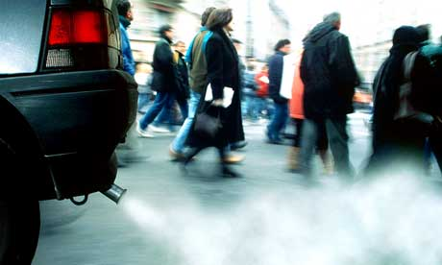
Carbon Dioxide
Carbon dioxide is a gas that all living things give off into the air. This gas makes up less than 1% of the air in our atmosphere, but it is a very important gas. When we burn gasoline in our cars, carbon dioxide gas is given off into the air.
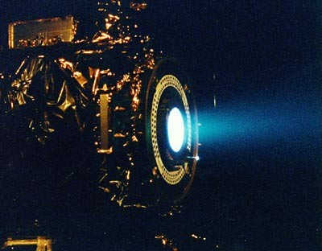
Nitrogen
There is a lot of nitrogen gas in our atmosphere. Nitrogen makes up 78% of the molecules in the air around us. Some rockets give off nitrogen gas. Satellites that orbit Earth also use nitrogen gas to move around space.

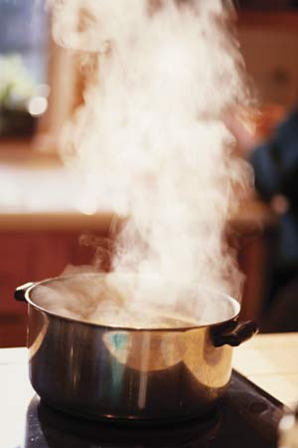
Water Vapor
Water vapor is one of the three states of matter for water. It is the gas form of water. Water vapor molecules make up 0-3% of the air in the atmosphere. Water vapor gas is invisible but when these gas molecules condense they form tiny droplets that we can see as steam, fog, or clouds.

Name: ______________________________________________ Date: __________

How Is Air Changed?

Now that you know air is a mixture of gases, think about how plants, animals, decomposers, and flames change this mixture. Write your ideas below.
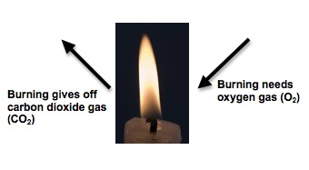

Burning Fuels & Flame
1. Look at the arrows going into and out of the flame. Oxygen is needed to burn things and carbon dioxide is given off. How does a flame change the mixture of air around it?

____The flame uses oxygen from the air and it gives off carbon dioxide and water vapor, so there is less oxygen and more carbon dioxide and water vapor__________________________
____________________________________________________________________________
____________________________________________________________________________

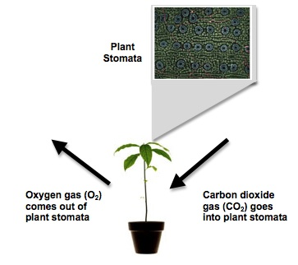

Plants
2. Look at the arrows going into and out of the plant. You may have heard that plants take in carbon dioxide and give off oxygen. How does the plant change the mixture of air around it?

___ The plant uses carbon dioxide from the air and it gives off oxygen, so there is less carbon dioxide and more oxygen in the air. _______________________________________________
____________________________________________________________________________
____________________________________________________________________________
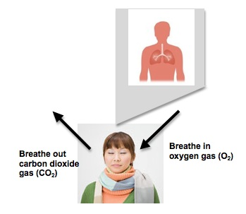

Animals
3. Look at the arrows going into and out of the person. You may have heard that people and other animals breathe in oxygen and breathe out carbon dioxide. How does a person change the mixture of air around them?

__ People use oxygen from the air and it give off carbon dioxide, so there is less oxygen and more carbon dioxide in the air around the person. ____________________________________
____________________________________________________________________________
____________________________________________________________________________
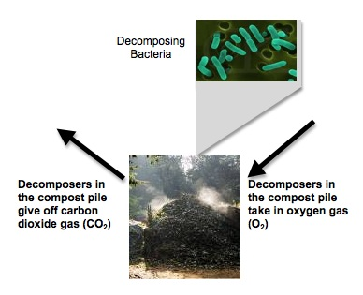
Decomposers

6. Look at the arrows going into and out of decomposers in the compost pile. Decomposers need oxygen to decompose dead plants and animals. They give on carbon dioxide. How do decomposers change the mixture of air around them?

__ Decomposers use oxygen from the air and it give off carbon dioxide, so there is less oxygen and more carbon dioxide in the air around the decomposers. ___________________________
____________________________________________________________________________
____________________________________________________________________________

